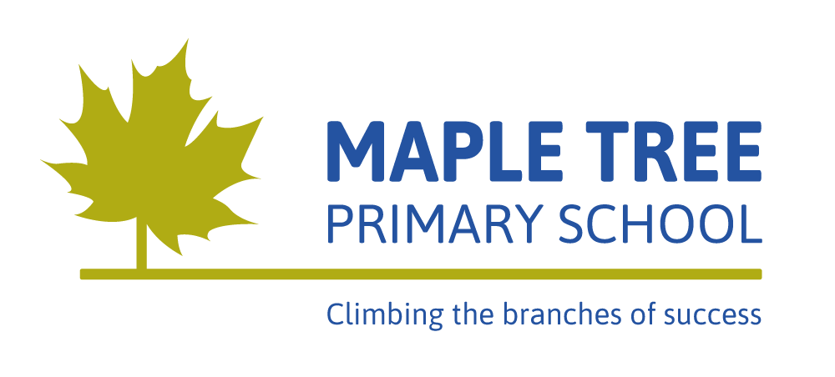
Long Term Curriculum - Upper Key Stage 2 - Year 5
 | Autumn 1 | Autumn 2 | Spring 1 | Spring 2 | Summer 1 | Summer 2
Topic | Ancient Greece (History) |  | Space Presenters (Science) |  | Biomes and Climate Zones (Geography)
English | Greek Myths and Legends  Non-fiction texts  Diary |  | Non-fiction information texts  Biographies and autobiographies  Poetry |  | Fictional stories  Newspaper articles  Non-chronological reports
Maths (not related to topic) | Place value  Addition & Subtraction  Statistics  Multiplication & Division  Perimeter and Area |  | Multiplication & Division  Fractions  Decimals & Percentages |  | Decimals  Properties of shape  Position & Direction  Converting units  Volume
Science | Living things and their habitats. | Animals including humans. | Earth and space. | Forces. | Properties of materials. | Changes of materials.
Art, Design and Technology | Creating clay pots.  Designing Greek clothes. |  | Create a model of the solar system.  Explore space artists. |  | Earthquake proof buildings.  Making own biomes.  Art from around the world.
Geography | Expansion of the Greek empire and people’s impact on the environment (changes over time). |  | Recognise the different shapes of countries.  Time zones.  Day and night. |  | Weather patterns and climate.  Compare UK to North America.  Rivers and coasts.
History | Place events on a timeline.  Compare Ancient Greece to modern day.  Explore Olympics. |  | Space exploration over time.  Famous space explorers over time. |  | History of natural disasters.
Computing | E-safety | Plan an event | Making a game on Scratch | Coding | Digital literacy | Scratch project
Music | Classic rock songs | Singing | Pop ballads | Singing and playing instruments | Singing, improvising, composing and performing. | Consolidating music skills.
Physical Education (P.E) | Outdoor Ed  Football | Tag Rugby  Badminton | Gymnastics | Dodgeball  Dance | Tri golf  Basketball | Athletics  Rounders & cricket
Personal, Social, Health, Citizenship Education  (P.S.H.C.E) | Health and Wellbeing. |  | Relationships. |  | Living in the wider world.
Languages (French) | Getting to know you | All about ourselves | That’s tasty | Family and friends | School life | Time travel
Religious Education  (R.E) | Why do some people believe in God and some people not? | What helps Hindu people as they try to be good? | How do Christians decided how to live? What would Jesus do? | What do Christians believe Jesus did to save people? | How and why do some people inspire others? Examples from Hindus, Sikhs, Jewish and others. | Values: What matters most to Humanists and Christians? Christians and non-religious people

