 SEND NEWSLETTER0
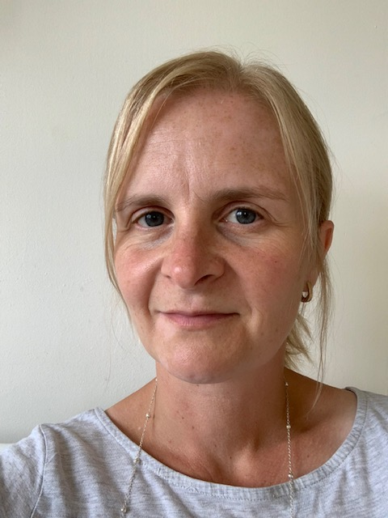
Link to current Central Beds SEND Newsletter containing info about local events and family support: https://content.govdelivery.com/accounts/UKCBCC/bulletins/2eea1b7

Theraplay corner:
Theraplay was developed to support healthy child/caregiver attachment. Strong attachment between the child and important adults in their life is believed to be the basis of lifelong good mental health and builds resilience. In each issue I would like to share a couple of Theraplay activities for you to try at home that are used in school

‘Draw’ the weather on each other’s back. Child faces away from adult and adult draws (using fingers/hands) the weather gently on their back (talk it through first). Then child draws the weather on the adult’s back:
- Sunshine - draw the sun
- Rain - tap back with the tips of your fingers
- Wind - rub back with sweeping motion across their back
- Snow - draw fingers down back
- Lightning - draw zig-zags across back
- Thunder - gently put your fists into back
- Clouds – draw shapes on back
Newspaper punch: Parent holds up (2 pages) piece of newspaper out to one side of their body. On the count of 3 the child punches a hole through the paper. The child then rolls the paper up into a ball and take turns throwing it in a ‘hoop’. This could be the bin/box. Can the child punch a hole in 5 sheets of paper in 30 seconds – have a few practises!
Dear Parents and Carers,
This is the first edition of the school’s newsletter focusing on Special Educational Needs and Disability (SEND). For those of you who don’t know me, I thought I would introduce myself, provide an outline of my role and how to contact me. I have worked at Maple Tree since 2008 in various roles across all the year groups, including Nursery Teaching Assistant, 1:1 Teaching Assistant and Qualified Teacher. I am passionate about working with and advocating for pupils with SEND (and their families) as my youngest son was diagnosed with Autism in 2006 and the barriers faced in accessing services/support for him (even now) means that I really understand and empathise the journey faced by pupils with SEND and their families, from a parent and a professional perspective. I am delighted to be the school’s full-time SENDCo (Special Educational Needs Co-ordinator) and this means, that with having completed the National SEN Award, my role includes co-ordinating provision/support for pupils with SEND, liaising with their parents, educational psychologists and external agencies.
This monthly newsletter aims to provide info for families by focusing on different areas of SEND in each issue, according to the SEND calendar below. I will give info about the SEND process and where to find further info or support services. Across the school, I aim to raise awareness of SEND and celebrate neurodiversity by highlighting these days/weeks,
which I will mark during Assembly time. With no dates for September, I will focus below
on the first three listed for October. Each month, there will also be a ‘Tech Corner’ recommending apps and
websites and ‘Theraplay Corner’ for you and your child to try out at home. I hope to include more features
as the school year progresses and welcome any suggestions from you. Please share any feedback with me
on 01767-699806 or email send@mapletreeprimaryschool.com If you have any queries/concerns about
your child’s learning needs, please speak to their class teacher initially. Kind Regards, Chris Pond.

A basic guide to Special Needs Support (more info in future newsletters):
Stage 1/QFT (Quality First Teaching): some additional or different intervention within the class will be put in place to enable the pupil to access independent learning and curriculum.
Stage 2 - builds on the arrangements for Stage 1 and the teacher and SENDCo consult with the parent and pupil to create a SEND Support Plan and are recorded on the school’s SEND Register. The outcomes, interventions and support should be agreed, with a date for review.
Stage 3 – interventions at Stage 2 have had little or no impact for at least 2 reviewed terms and an EHC (Education, Health and Care) Needs Assessment can be requested from the local authority. This builds on Stage 1 and Stage 2 support to enable schools to make provision for pupils with complex needs. It is appropriate only for pupils with long-term needs and the severity of the pupil’s special education needs means the Local Authority become involved with prolonged multi-agency involvement.
Please have a look at our school website under the ‘Inclusion’ tab for information about provision for SEND at Maple Tree and also the school’s SEND policy and annual SEND Report. There are links to useful websites, in particular, the Central Beds Local Offer which I have attached here Local Offer (PDF 487.7KB) It sets out what local support/services are available for Children & Young People with SEND.
September 2021
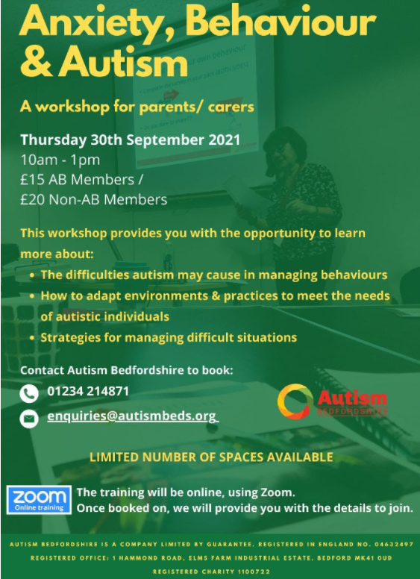
CHUMS are running some psychoeducation workshops for families who are registered at a GP Surgery in Central Bedfordshire or Bedford Borough. Please complete the attached registration form and return to: fwteam@chums.uk.com along with their preferred dates. There are dates for the same workshops for older children –please let me know if you would like these dates.
Parent Sleep Workshop (Children aged 12 and under) - The workshop will cover the following topics; why sleep is important, what is ‘good’ sleep, possible causes of sleep difficulties and learning strategies to help overcome sleep problems.
- Monday 27th September 9:30-11:30am
- Tuesday 7th December 17:00-19:00pm
0-5 Resiliency Workshop (Parent’s only) - The workshop will look at the importance of relationships, healthy attachment and how children are constantly learning from those around them, eg. emotional regulation, how parents/carers can model healthy emotional regulation and behaviours. The workshop will cover strategies/techniques to help build resiliency in children.
- Thursday 28th October at 17:00-19:00pm
Primary Resiliency Workshop (Parent workshop for children aged 6-12) – The workshop will cover the following topics; mental health vs mental health problems, emotional regulation, psychoeducation around anxiety/low mood, relaxation strategies.
- Thursday 9th September at 9:30am – 11:30am
There is a Specialist Nursing and Early Support Service Child Development Centre that can help families with sleep and behaviour issues at Ivel Valley HUB, Ivel Valley School (Primary Site), The Baulk, Biggleswade, SG18 0PT. Last Monday of the month (09.30 – 11.30am). Tel: (01234) 310278

Developmental co-ordination disorder (DCD), known as dyspraxia, affects physical co-ordination. A child performs less well than expected in daily activities for their age and seem to move clumsily, e.g. poor balance, poor posture, fatigue, clumsiness, differences in speech, perception problems, poor hand-eye coordination. Further info can be found at: https://dyspraxiafoundation.org.uk/

Calendar for October 2021:
5-11 – Dyslexia Awareness Week
6-12 – Dyspraxia week
6 – World Cerebral Palsy Day
8 – World Sight Day
10 – World Mental Health Awareness Day
22 – International Stammering Awareness Day
Dyslexia is a common learning difficulty that can cause problems with reading, writing and spelling. It's a specific learning difficulty, meaning it causes problems with certain abilities used for learning: reading and writing. Unlike a learning disability, intelligence isn't affected. At Maple Tree, we use a simple dyslexia screener which can indicate the extent of a literacy difficulty and provide more targeted learning support. Further formal diagnosis can only currently be privately assessed by a Specialist Dyslexia Assessor. Our classes are inclusive for all learners and are ‘dyslexia-friendly’ where teachers:
Use visual aids Plan for inclusive homework Avoid rote-learning
Use dyslexia-friendly fonts Mark based on content
Avoid forcing children to read in front of the whole class
Provide a clear line of sight for non-verbal communication
Provide memory clues like alphabet and numbers
Schedule natural breaks Speak more slowly in simple sentences
Further information to support your child at home can be found at: https://cdn.bdadyslexia.org.uk/uploads/documents/Empowered-Parents-2021.pdf?mtime=20210617145306&focal=none

Cerebral Palsy is the name for a group of lifelong conditions that affect movement and co-ordination. It's caused by a problem with the brain that often develops before, during or soon after birth, or due to meningitis or a serious brain injury. Some people only have minor problems, while others may be severely disabled. Symptoms can include: delays in reaching development milestones – e.g. not sitting by 8 months or not walking by 18 months, seeming too stiff or too floppy, weak arms or legs, fidgety, jerky or clumsy movements, random controlled movements, walking on tiptoes, a range of other problems – swallowing difficulties, speaking problems, vision problems and learning disabilities. Further information and support can be found at: https://www.scope.org.uk/advice-and-support/cerebral-palsy-introduction

TECH CORNER:
Apps For Dyslexia:
https://www.callscotland.org.uk/common-assets/cm-files/posters/ipad-apps-for-learners-with-dyslexia.pdf
https://www.callscotland.org.uk/common-assets/cm-files/posters/using-the-ipad-to-support-dyslexia.pdf
Apps for Dyspraxia:
http://gaa.org.uk/wp-content/uploads/2020/05/ipad-apps-for-learners-with-dyscalculianumeracy-difficulties.pdf

CHUMS Psychoeducation Workshop Registration Form
Child’s First Name

Child’s Surname

Child’s DOB (DD/MM/YYYY)

Gender

Parent/ Carer Name and Relationship

Email Address

Telephone NO.

Home Address

GP Surgery

Ethnic Origin

Nationality

Main Language
(Also, if not English do you require a translator?)

Current School

New School in September 2021

Does your child have an Educational Health & Care Plan? | YES / NO
Is your child known to Early Help / Social Services? | YES / NO
If known to Social Services, is your child considered a “Looked After Child”? | YES / NO
Are you currently in the process of completing an Early Help Assessment? | YES / NO
Does your child have any diagnosed learning disabilities (e.g. dyslexia)? | YES / NO
Does your child have a formal diagnosis of ADHD? | YES / NO
Does your child have a formal diagnosis of ASD? | YES / NO
Workshop you wish to attend
(Please state parent sleep workshop, 0-5 resiliency etc.)

Date you wish to attend workshop on

