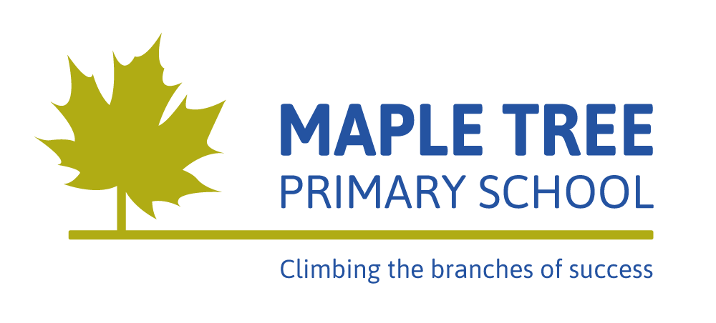
Yearly Overview Year 5 2025-2026
 | Autumn 1 | Autumn 2 | Spring 1 | Spring 2 | Summer 1 | Summer 2
Core School Values | September: Kindness and Cooperation  October: Thankfulness | November: Friendship and Sharing  December: Respect | January: Unity  February: Responsibility | March: Hope and Peace  April: Patience and Perseverance | May: Trust and Honesty | June: Happiness  July: Courage
British Values  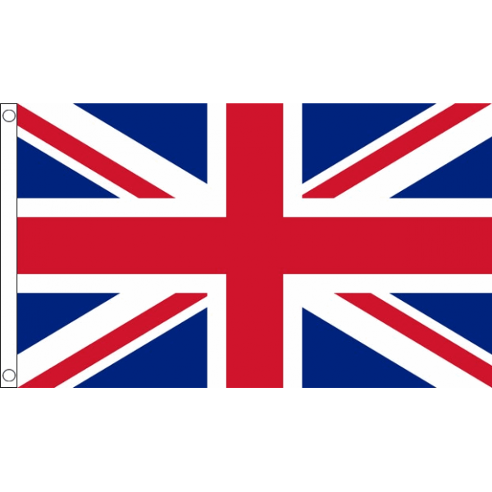 | Democracy | Tolerance | Mutual Respect | Rule of Law | Individual Liberty | Rule of Law
Learning Launch/Outcomes (including enrichment days and trips) | STEM Space Centre |  | Star Gazing at school |  | Swimming
Writing Genres | Cosmic Science Fiction (Narrative – story ending )  Highwayman – Classic Poetry  (Narrative – emotive language) | Scott of the Antarctic – Non Fiction (Diary entry)  The Snowman – Modern Classic (instructions) | Arctic Animals- Non-Fiction (Non-chronological report)  Greek Myths and Legends  (Narrative - tragedy) | Greek Myths and Legends  (Narrative – comedy dialogue) | David Attenborough – Non-Fiction  (Biography and Autobiography) | Plastic Pollution (Speech – persuasive techniques)
Personal, Social, Health, Citizenship Education  (P.S.H.C.E) | Setting Rules and signposting  Families and relationships |  | Economic wellbeing  Citizenship |  | Health and wellbeing  Safety and the changing body
Maths | - Place Value  - Addition and Subtraction | - Multiplication/Division (multiples, factors, prime, square and cube numbers)  - Fraction (equivalent, improper, mixed, adding and subtracting) | - Multiplication/ Division (multiply by 2 or 3 digit numbers, short division, remainders and efficient division)  - Fractions (multiplying, fraction quantities, fraction amounts and find the whole) | - Perimeter and area  - Decimals and Percentages  - Decimals | - Shape  - Position and direction  - Decimals | - Negative numbers  - Converting Units  - Volume
Science  (including study of key scientists) | Space | Forces | Living things and their habitats | Animals including humans | Properties and changes of materials
History | Were the Vikings raiders, traders or something else? |  | What did the Greeks ever do for us? |  | What was life like in Tudor England?
Geography | What is life like in the Alps? |  | Would you like to live in the desert? |  | Why do Oceans matter?
Computing | Online Safety |  | Algorithms |  | Computer Programming
Art  (including artists) | Drawing -Year-5-Typography-and-Maps |  | Textiles -Year-5-Fashion-Design |  | Paint -Year-5-Land-and-City-Scapes
Design and Technology | Structures - Bridges |  | Mechanical systems – Pop up mechanisms |  | Digital World - Micro bits
Music  (Inspiring Music Online) | Composition |  | Looping and remixing |  | Musical theatre
Physical Education (P.E) | Football | Badminton | Dance | Gymnastics | Basketball & Netball | Rounders and Athletics
Religious Education (R.E) | What does it mean if Christians believe God is holy and loving? | What helps Hindu people as they try to be good? | How do Christians decided how to live? What would Jesus do? | What do Christians believe Jesus did to save people? | How is faith express in Islam? | How and why do some people inspire others? Examples from Hindus, Sikhs, Jewish and others.
MFL (KS2 only) | Les Commandes de la Classe et la phonétique (Classroom commands and phonetics) | La date  (The date) | Chez Moi  (My home) |  | Les vetements  (Clothes)

