Mental Health Focus May – BREATHING
With your class please use these daily breathing techniques at morning and/or afternoon registration explaining that practicing breathing exercises can lead to better mental health, positive emotions and alleviate stress. Breathing exercises can also allow you to think more clearly and reduce feelings of worry. Sit comfortably and…
Wb. 2/5/22:
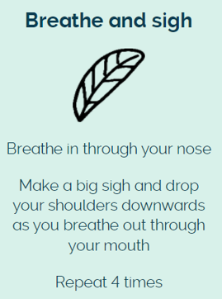
Wb. 9/5/22:
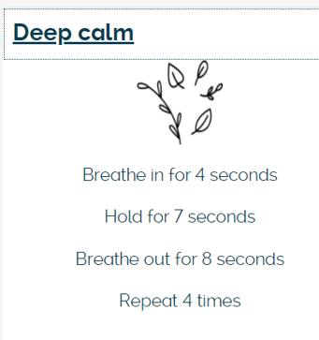

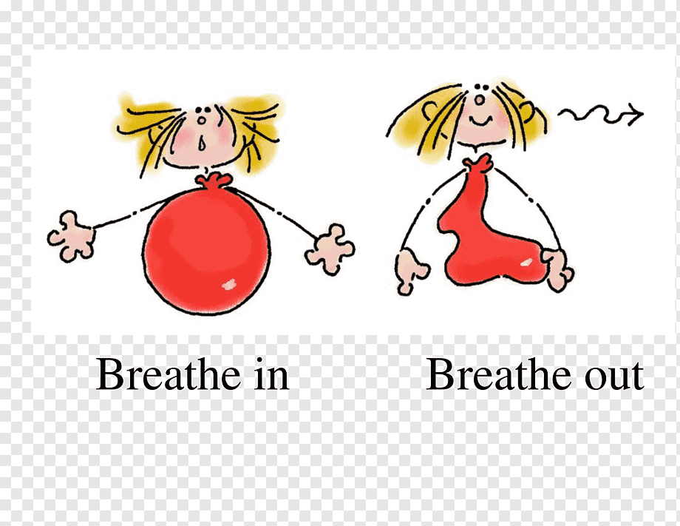
Wb. 16/5/22:
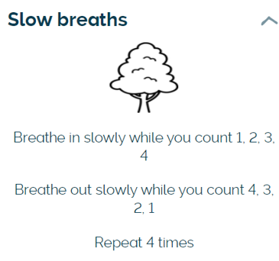
Wb. 23/5/22:
